Join Father David De Julio

DANUBE DELIGHTS
8 day itinerary | Budapest to Munich | EWNB.2 | August 28, 2027

Emerald Dawn

The EmeraldEXPERIENCE

7 Number of nights River Cruise Coach transfer
$X,XXX
$X,XXX
Map  CAT | is a guide only  Stateroom/Suite | Deck | Group Fare
E | Emerald Stateroom | Riviera | $3,545
D | Emerald Stateroom | Riviera | $3,895
C | Emerald Panorama Balcony Suite | Vista | $4,595
B | Emerald Panorama Balcony Suite | Vista | $4,795
A | Emerald Panorama Balcony Suite | Horizon | $4,945
S | Grand Balcony Suite | Horizon | $5,945
SA | Owner’s One-Bedroom Suite | Horizon | $7,045

This insightful itinerary crosses into four countries, offering a unique perspective into their past and present simultaneously. Guided walks along the cobblestone streets of Germany tell their own story, and city tours of Vienna and Budapest exemplify how the past can shape the future. Celebrate the ancient as it
co-exists with the modern in the Austrian and Hungarian capitals, and gain a personal understanding of why the iconic Danube has acted as inspiration
to so many.
- 7 nights on board an Emerald Cruises Star-Ship
- All Meals included while onboard our Star-Ship
- Complimentary wine, beer and soft drinks to accompany lunch & dinner on board
- Complimentary tea & coffee on board
- Complimentary water provided on board and during excursions
- A variety of onboard evening entertainment
- Complimentary Wi-Fi on board
- An excursion almost every day
- First-class service from an English-speaking crew and knowledgeable local guides
- Earn EmeraldEXPLORER loyalty points
- All port charges and taxes
- All gratuities are included
$X,XXX

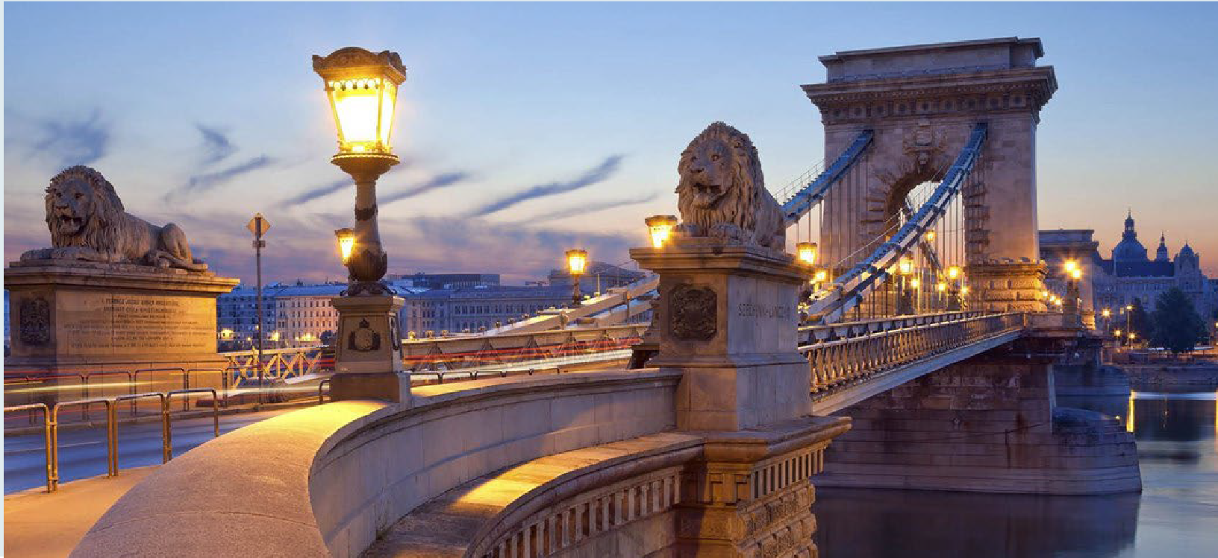
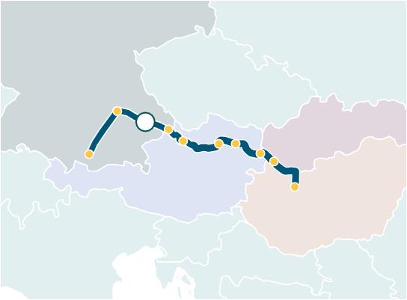
GERMANY
Regensburg
7 Passau Dürnstein
Krems
Munich
Engelhartszell
SLOVAKIA
Bratislava
Vienna
AUSTRIA
Budapest
HUNGARY

Pricing is per person. Included in the above group fares is a per person port charge of $374
$X,XXX
$X,XXX
$X,XXX
$X,XXX
MAKE FINAL PAYMENT 10 MONTHS PRIOR TO DEPARTURE FOR ADDITIONAL PAY IN FULL BENEFITS.
Ask for details.

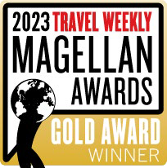


Helene Riley, Travels with Helene AIR IS INCLUDED
352-556-3111 DISCOUNTS WILL BE
travelswithhelene@gmail.com ADDED

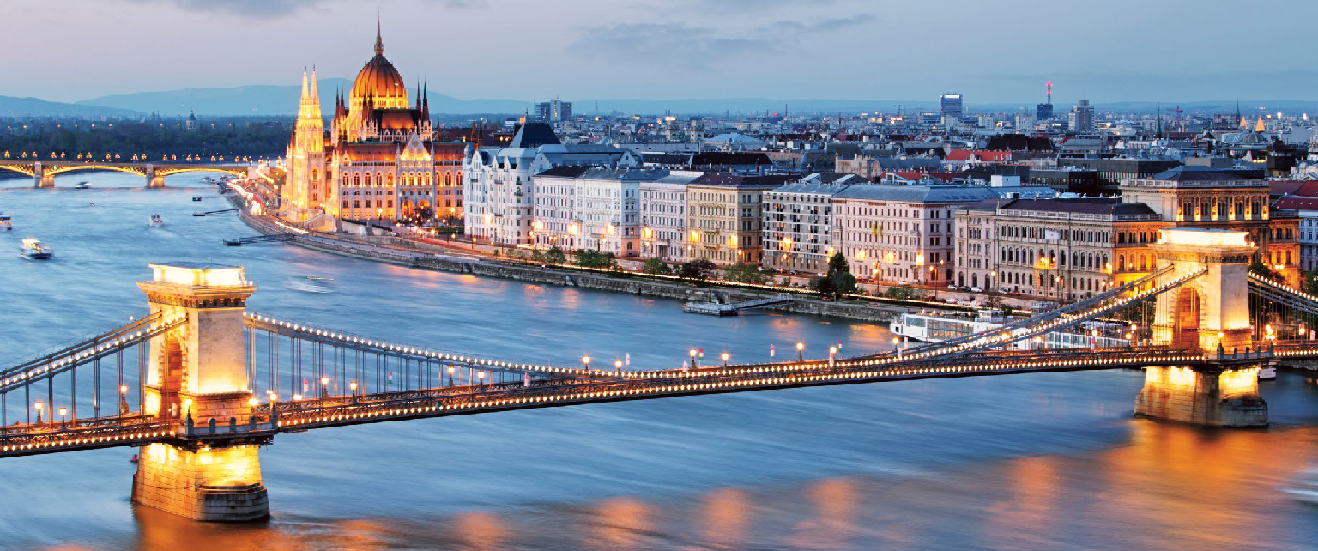
Hungary, Budapest

Day 1 Budapest
Welcome to Budapest, where you’ll be met at the airport and transferred to your contemporary Emerald Cruises Star-Ship
before enjoying plenty of free time to explore the Hungarian capital at your leisure.
Enjoy an authentic Hungarian folklore show on board this evening, followed by a traditional dinner.
 Traditional Hungarian folklore show on board
Meal: Breakfast
Please book your flight to arrive in Budapest before 5:00 PM.
Day 3 Bratislava
This morning, relax on board as we sail to Bratislava. An ancient landscape awaits, where remarkable towers add to a skyline that perfectly encapsulates the city’s history, and preserved medieval fortifications tell tales
of a turbulent past. Your local guide will take you through the heart of the city, as you soak in the sights of the lavish Episcopal Summer Palace and the neo-Renaissance façade of the Slovak National Theatre.
If you’re feeling more active, you could instead choose to hike around the serene gardens of Bratislava Castle, which provides the perfect
The Austrian capital is an art-lover’s dream, and your guided tour will include a visit to the Kunsthistorisches Museum, the largest art museum in the country and one of the most important museums worldwide.
If you’re feeling more active, then you may opt to explore on two wheels instead,
cycling along the riverbanks before touching on Danube Island and Prater, the famous Viennese amusement park, home to the traditional 19th-century Ferris wheel.


 Vienna art tour with a visit to the Kunsthistorisches Museum
Guided bike tour in Vienna

setting for the Shakespeare festival that

Day 2 Budapest
Architecture from across the centuries illuminates the history of the Hungarian capital. Initially, two separate cities, Buda to the west and Pest to the east offered incredibly different views on the culture of one of the liveliest cities in Eastern Europe. Today, you’ll be able to explore the city during a guided tour, including Heroes’ Square, the UNESCO World Heritage-listed Andrássy Avenue, and the Buda Castle District. Alternatively, enjoy a hike to Gellert Hill for a postcard-worthy panorama view of the Danube banks.

Guided coach tour of Budapest Hike to Gellert Hill
Meals: Breakfast, Lunch, Dinner
occurs during the summer months.
This afternoon, you will be invited into the home of a local family to learn more about their traditions and culture over coffee and cake.

Walking tour of Bratislava


Home-hosted coffee and cake with a local family
Guided hike to Bratislava Castle
Skoda tour of post-Communist Bratislava (extra expense)
 Carpathian wine route (extra expense)
Meals: Breakfast, Lunch, Dinner

Day 4 Vienna
Sweeping boulevards and world-famous art exhibitions welcome you to Vienna, a city that
Viennese evening concert (extra expense)
Meals: Breakfast, Lunch, Dinner

Day 5 Krems - Dürnstein
Enjoy a guided tour of Göttweig Abbey this morning. It is a true treasure overlooking the UNESCO World Heritage-listed Wachau
Dave Lubchansky
2026-02-02 13:26:45
--------------------------------------------
Au
Valley. Visible from a great distance, it’s one of Austria’s most important Benedictine abbeys, attracting visitors from all over the world and providing epic panorama views.
Afterward, your Star-Ship will sail through the fascinating Wachau Valley, part of the UNESCO World Heritage-listed Wachau Cultural Landscape, and on to Dürnstein.
Alternatively, embark on a guided bike tour

perfectly encapsulates the opulence of the
Habsburg Monarchy and its ornate Baroque palaces.
in the Wachau region, passing terraced
vineyards, castles, and ruins before arriving at your Star-Ship docked in Dürnstein.

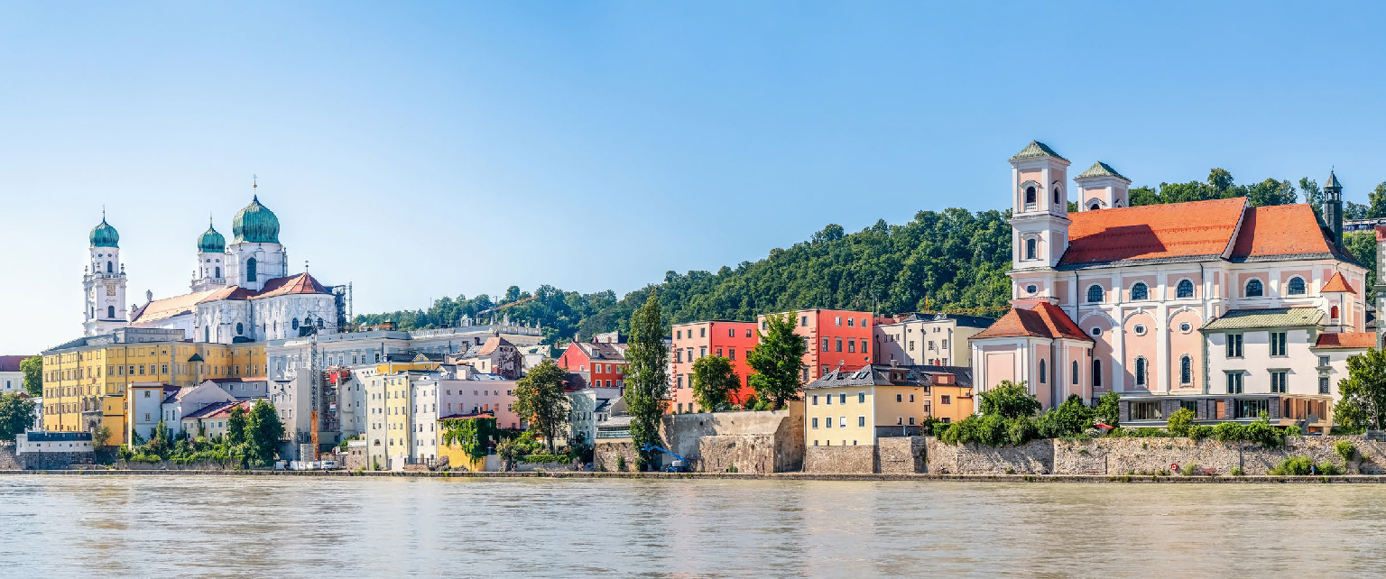
Passau, Germany

In the afternoon we arrive in Dürnstein; a small town nestled in the heart of the
Wachau wine region. You’ll have the chance to hike to the medieval ruins of Dürnstein Castle, the site where King Richard I was held prisoner following his return from the Third Crusade, and part of the UNESCO World Heritage-listed Wachau Cultural Landscape, a place peppered with natural lookout points that highlight the beauty of the region.

Guided tour of Göttweig Abbey Guided hike to Dürnstein Castle Guided bike tour along the Danube
Meals: Breakfast, Lunch, Dinner

Day 6 Engelhartszell - Passau After a morning of sailing along the Danube, we will take you into the heart of Passau.
Nicknamed the Dreiflüssestadt, meaning the
‘the city of three rivers,’ it’s situated at the confluence of the Danube, Inn, and Ilz rivers.
Your included guided tour of Passau will unveil its noteworthy Gothic and Baroque architecture. If you’re feeling active, you could join a bike tour along the River Inn, one of the three rivers converging in Passau.
After your tour, enjoy some free time to explore Passau at your leisure before spending an evening sailing blissfully toward Regensburg.

Guided tour of Passau
Guided bike tour along the River Inn
Visit to Schuetz Museum Engelhartszell (extra expense)
Excursion to the Bavarian Forest (extra expense)
Meals: Breakfast, Lunch, Dinner

Day 7 Regensburg
This morning, we arrive in Regensburg, a city built on the site of an ancient Roman fort. Your guided walking tour of Regensburg will showcase its UNESCO World Heritage-listed medieval center, where narrow cobbled lanes and tall
façades help to define the character of this enchanting Bavarian city. We will stop for a local Bavarian sausage tasting so you get a natural feel of the daily life
in Regensburg.
Alternatively, you could join a bike tour to the Walhalla monument, which towers high above the slopes of the Danube.
From here, you can enjoy a fascinating view of the surrounding landscape and river. This evening, enjoy a traditional Bavarian band performance on board.
Walking tour of Regensburg with Bavarian sausage tasting.
 Traditional Bavarian band performance on board
 Guided bike tour to the Walhalla monument
Meals: Breakfast, Lunch, Dinner

Day 8 Regensburg Disembarkation
- Munich
After breakfast, it’s time to say farewell to your fellow guests and disembark your Star-Ship for your transfer to the airport, taking memories of Roman architecture and the rich culture of the Danube River with you.
Meal: Breakfast
Please book your flight to depart out of Munich after 12:00 PM.

The itinerary is a guide only and may be amended for operational reasons. As such Emerald Cruises cannot guarantee the cruise will operate unaltered from the itinerary stated above. Please refer to our terms and conditions for further information.





Key:

Terms and conditions: A non-refundable initial deposit of $500 per person is required at the time of booking, with full payment required 90 days before departure. This offer is not combinable with any other offer. Offer available to residents of the 50 United States & Washington D.C. only. Offer may be extended, canceled, or withdrawn without notice. Pricing is correct at the time of print. Visit emeraldcruises.com/terms-and-conditions for complete terms and conditions. 240159-3 - Month XX, 202X

